**System Login**

The account user or admin can login to the inventory management system following below steps:

1. Open the system and following page will be displayed

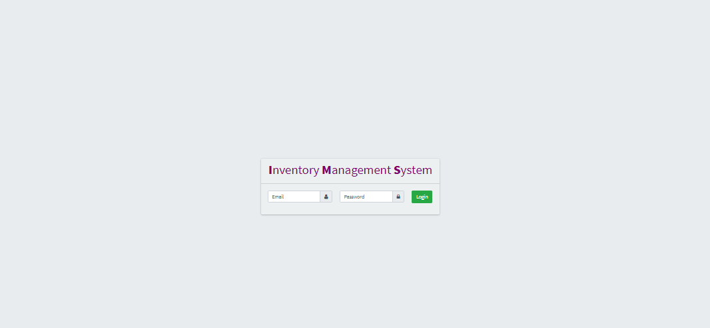

1. Enter your user id and password and click **Login**

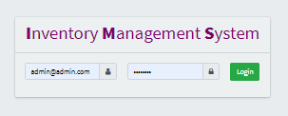

1. You will be logged in and you can see the following page

